Summary of the Science Demonstrating that Refined Sugar
Does Not Contain Genetic Material
The U.S. Beet Sugar Industry’s principal objective is to produce high quality products that meet the standards our customers and consumers demand. Through our commitment to best practices and continuous improvement we are global leaders in sustainable beet sugar production. To that end, we integrated biotechnology into our farming practices which has allowed us to use less water, fertilizer, pesticides, and fuel, while producing healthier plants on less acres. Before doing so, however, we carefully examined the science and conducted extensive testing to ensure that refined sugar produced from bioengineered sugarbeet plants is identical to refined sugar produced from conventional sugarbeets, cane sugar, and organic sugar from U.S. sugar producers and major foreign suppliers. The science and testing confirm that all plant genetic material (DNA and protein) is removed early in the sugar refining process. Thus, regardless of whether the plant from which the sugar (sucrose) is derived is biotech or otherwise, the resulting sugar molecule is identical in all cases.
The following summarizes the science and testing that has been conducted demonstrating that refined sugar, whether derived from bioengineered sugarbeets or cane, does not contain genetic material.
Introduction
In promulgating regulations implementing the National Bioengineered Food Disclosure Standard, Pub. L. 114-216, the U.S. Department of Agriculture, Agricultural Marketing Service (AMS) reviewed the published peer-reviewed science demonstrating that genetic material is not detectable in refined beet sugar or refined cane sugar. AMS concluded that “based on the available scientific evidence, refined beet and cane sugar, . . . are unlikely to require BE food disclosure because the conditions of processing serve effectively to degrade or eliminate the DNA that was initially present in the raw agricultural commodity.” 83 Fed. Reg. 65,814, 65,834 (Dec. 20, 2018). AMS further explained that,
the sugar refining process from sugar beet or sugarcane juice [is] extracted by pressing or diffusion, then clarified and evaporated, [which] results in sucrose of 99.9% purity. Several of these refining steps involve heating which serves to degrade DNA. Additionally, prior to crystallization, lime is used to remove the impurities remaining in the sugar juice; DNA and protein are effectively removed at this step in the sugar refining process.
Id. Based on the scientific evidence, several international regulatory regimes (Japan, Canada, Australia, Brazil, etc.) have determined that beet or cane sugar derived from a biotech plant, does not contain bioengineered DNA or protein and therefore is not subject to disclosure under their regulations. In addition to the published scientific findings, the U.S. Beet Sugar Industry conducted comprehensive testing of refined sugar from all of the North American beet sugar factories that confirm the absence of DNA and protein in the refined beet sugar.
Details of the scientific studies and the beet sugar industry testing is provided below.

The Peer-Reviewed Scientific Literature Establishes the Lack of Genetic Material in Refined Sugar
AMS cited to a number of studies that demonstrate the absence of genetic material in refined sugar. These include a study conducted by German scientists that examined the fate of DNA and protein during the standard purification steps of the sugar extraction process from both conventional sugarbeets and sugarbeets genetically engineered with the coat protein CP21 to confer resistance to a certain virus. (Klein, J., et al. 1998). This study is particularly important because it not only failed to detect DNA and protein beyond the early raw juice stage of the refining process, it estimated that the beet sugar clarification process had the potential to reduce the amount of sugarbeet DNA by a factor of ten to the fourteen (a hundred trillion or 0.00000000000001), which exceeds the total amount of DNA present in sugarbeets. AMS also cited Oguchi, et al. (2009) that also found that sugarbeet plant DNA is degraded and removed early in the sugar extraction process and is therefore not present in the finished sugar. The Oguchi study was the basis upon which Japan exempted beet sugar from its mandatory GMO labeling requirements.
With respect to sugar produced from sugarcane, AMS cited to Joyce, et al. (2013) and Taylor et al. (2009) demonstrating the absence of genetic material in refined cane sugar. In addition, Pauli et al. (2000), did not find DNA in either raw or refined cane sugar.
The science is further confirmed by a study published in March 2018. (Cheavegatti-Gianotto, et al. 2018). Specifically, Brazilian researchers examined whether sugar produced from sugarcane genetically modified to express the Cry1Ab protein to control the sugarcane borer (Diatraea saccharalis) contained transgenic material. The study found that clarified juice, molasses, and raw sugar showed no detectable levels of Cry1Ab protein. Similarly, no heterologous DNA was detected in clarified juice and downstream products including raw sugar. As the researchers concluded, the results are in agreement with the results of other studies that investigated the degradation of specific DNA fragments inserted into genetically modified sugarcane (NptII) and glyphosate-resistant sugarbeet (CP4 EPSPS) that reported the complete elimination of the inserted DNA during processing to refined sugar (Klein et al., 1998; Oguchi et al., 2009; Joyce et al., 2013). Brazil, as the largest producer and exporter of cane sugar in the world, relied on the Cheavegatti-Gianotto study to determine that sugar produced from genetically modified sugarcane is a “chemically defined pure substance” that does not fall within the scope of Brazil’s Biosafety Law and therefore “is not a genetically modified organism or a derivative thereof.”
Finally, Cullis et al. (2014) examined the cane sugar refining process and “failed to detect any sugarcane DNA in refined sugar.” As Cullis concluded, the study’s failure to detect DNA in the refined sugar is consistent with previous studies on the detection of DNA through the refining process (Joyce et al. (2013), Klein, et al. (1998), Oguchi, et al. (2009).
The schematic in Figure 1 illustrates the steps in both the beet and cane refining processes and identifies the points in the process where studies have tested for genetic material. While there is some variability among the studies as to precisely when the DNA and protein are no longer detectable, largely based on the DNA extraction methods used, primer selection, and polymerase chain reaction (“PCR”) conditions and fragment length, all studies demonstrate that the genetic material is removed early in the refining processes for both beet and cane sugar.

Figure 1 Schematic of Beet and Cane Refining Processing Identifying Points Where Samples Have Been Taken to Test for Genetic Material
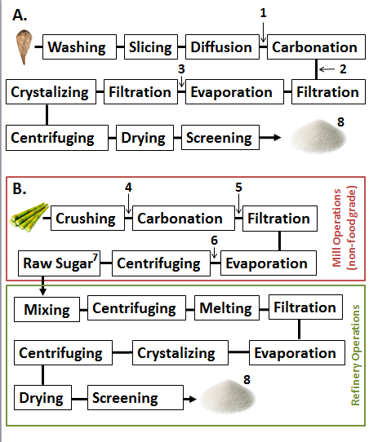

Beet processing (A) occurs all in one food-grade facility. Cane processing (B) occurs in two separate facilities: the mill (red box) and the refinery (green box). None of the products produced by the cane mill are considered or handled as food grade products.
Samples at various points in the refining processes have been analyzed to evaluate the presence of absence of DNA/proteins. Those samples for sugarbeet (A) include: Raw Juice (1), Thin Juice (2), Thick Juice (3) and Refined Sugar (8). Samples for sugarcane (B) include: Raw Juice (4), Clarified Juice (5), Syrup (6) and Refined Sugar (8). None of the studies have found genetic material in Refined Sugar (8).

Extensive Studies Conducted by the Beet Sugar Industry Establish the Lack of Genetic Material in Refined Beet Sugar
The beet sugar industry conducted three studies that show the absence of DNA and protein in refined beet sugar. While these studies have not been published in the scientific literature, they were conducted using methodologies validated according to Codex Alimentarius guidelines by an ISO/ICE 17025 accredited laboratory. In the first study conducted in 2008 samples were collected from eight different points in the refining process [three samples each at the beginning (sliced beet, pressed pulp, dried pulp), middle (raw, thin, and thick juice, and end (refined sugar and molasses)] at one processing facility. The study demonstrated that while transgenic DNA and the CP4-EPSPS protein was detected in the raw sugarbeet and the raw juice (Point 1 on Figure 1), it was not detected at any other subsequent point in the refining process. Thus, consistent with Klein et al. (1998), the study confirmed that the transgenic DNA and CP4-EPSPS protein are removed early in the process at the clarification stage during the transformation from raw juice to thin juice.
In the second study, multiple samples of sugar produced from transgenic and conventional sugarbeets and sugarcane from around the world were analyzed for the presence of plant (plastid) DNA. More specifically, the study sampled organic sugar from Europe, South America and the U.S.; turbinado/muscovado sugar from Africa, Mauritius, and the U.S.; white beet sugar from Canada, Europe, and the U.S. (including sugar produced from transgenic sugarbeets); and white cane sugar from Africa, Australia, Canada, the Caribbean, Europe, Japan, and the U.S. No plant DNA was detected in any of the samples, thus again confirming the Klein et al. (1998) findings that the clarification process effectively removes all plant DNA (by a factor of 10¹⁴).
In 2014, the Beet Sugar Development Foundation conducted a third study of all U.S. and Canadian beet sugar factories. Sixty-nine samples of refined sugar were collected from all North American beet sugar factories (three random samples from each of the 22 U.S. factories and the one and only Canadian factory) by the same independent analytic firm to test for any presence of transgenic DNA and the CP4-EPSPS protein. All 69 samples of commercial sugar tested negative for transgenic sugarbeet DNA, as well as the CP4-EPSPS protein. This comprehensive study reaffirmed the 2008 study and is consistent with the scientific literature that shows that there is no transgenic DNA or protein in the sugar extracted from transgenic sugarbeets.

Summary
Figure 2 provides a visual summary of the studies examining DNA and protein degradation during the sugar refining process. Because the studies use various terms to refer to similar stages of the refining process, the stages are aligned vertically to provide consistency across studies.
Figure 2 shows that all studies conclude that refined sugar, which is 99.9 percent sucrose, does not contain DNA or protein. These findings are not only scientifically sound, they make logical sense. Any product that is refined to a purity of 99.9% under continuous high heat and in the presence of native nucleases will not contain extraneous impurities or genetic material. Indeed, Klein et al. (1998) and other researchers explain that these two factors are responsible for eliminating genetic material from refined ingredients.
Seven peer-reviewed published studies demonstrating the lack of genetic material in refined sugar, as well as testing results from each of the 22 U.S. and one Canadian beet sugar processing factories unequivocally demonstrate that there is no transgenic DNA or protein in the sugar extracted from transgenic sugarbeets or cane. This body of science confirms that refined sugar is not a bioengineered food within the meaning of the National Bioengineered Food Disclosure Standard and therefore, as AMS itself recognized, is not subject to the mandatory disclosure requirements. Australia, New Zealand, Japan, Malaysia, South Korea, and Brazil have relied on one or more of these studies to conclude the refined sugar does not contain genetic material and therefore is not subject to their mandatory bioengineered food labeling laws.

Figure 2 Visual Summary of Science Demonstrating Lack of Genetic Material in Refined Sugar
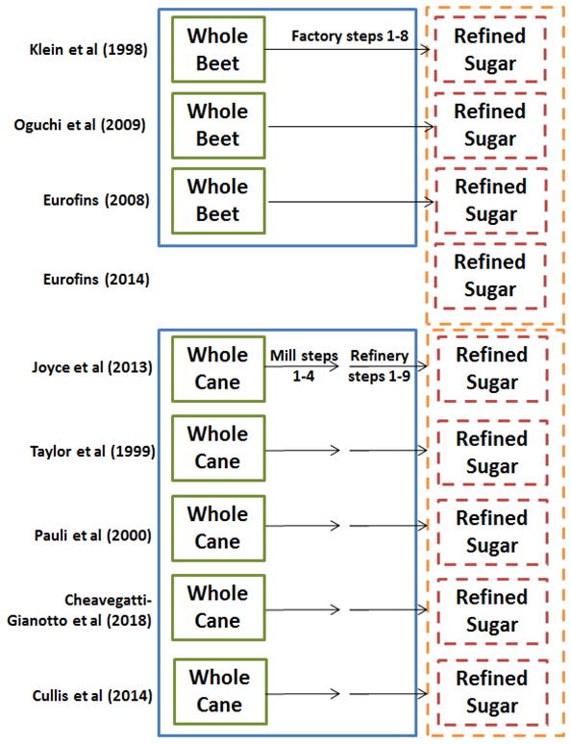

Klein, J., Altenbuchner, J., and Mattes, R., Nucleic acid and protein elimination during the sugar manufacturing process of conventional and transgenic sugarbeets. J. of Biotechnology, 60: 145-153 (1998).
Oguchi, T., et al., Investigation of residual DNAs in Sugar from Sugar beet (Beta vulgaruis L.), J. Food Hyg. Soc. Japan, 50: 41-46 (2009), available at https://www.jstage.jst.go.jp/article/shokueishi/50/1/50_1_41/_pdf.
In Japan, processed foods that contain detectable amounts of transgenic DNA or proteins must be labeled to indicate that genetically modified ingredients are used. Japan does not require sugar from transgenic sugarbeets to be labeled because the refined sugar does not contain transgenic DNA or proteins. USDA FAS “Japan, Agricultural Biotechnology Annual, Japan’s regulatory system for GE crops continues to improve”, https://gain.fas.usda.gov/Recent%20GAIN%20Publications/Agricultural%20Biotechnology%20Annual_Tokyo_Japan_7-13-2015.pdf.
Joyce, P.A., Dinh, S-Q., Burns, E.M., and O’Shea, M.G. (2013), “Sugar from genetically modified sugarcane tracking transgenes, transgene products and compositional analysis,” Proc. Int. Soc. Sugar Cane Technol.” Vol. 28, pp 1-9; Joyce, P.A., Sedl, J.M. and Smith, G.R. (1999), “Laboratory crystallized sugar from genetically engineered sugarcane does not contain transgene DNA”, Proc. Aust. Soc. Sugar Cane Technol., Vol. 21, pp. 502.
Pauli et al (2000) Extraction and Amplification of DNA from 55 Foodstuffs. Mitt. Lebensm. Hyg. 91: 491-501.
Cheavegatti-Gianotto, A., et al. “Lack of Detection of Bt Surgarcane CRY1Ab and Nptll DNA and Proteins in Sugarcane Processing Products Including Raw Sugar (2018), Frontiers in Bioengineering and Biotechnology, Vo. 6, Art. 24 (2018).
Cullis, C., Contento, A., Schell, M., DNA and Protein Analysis throughout the Industrial Refining Process of Sugar Cane. International Journal of Agricultural and Food Research, North America, 3, jul. 2014. Available at: https://www.sciencetarget.com/Journal/index.php/IJAFR/article/view/437.
Id. at 14.
Eurofins, a globally recognized leader in food, environment, and pharmaceutical testing, conducted the studies on behalf of the beet sugar industry. It is widely recognized for its expertise in qualitative and quantitative DNA analysis for determining whether genetically modified organisms are present in food.
The CP4-EPSPS protein confers Roundup® tolerance to the H7-1 Roundup Ready® sugarbeet plant.
Forty-four samples of sugar were analyzed, as well as four samples of laboratory pure (analytical grade) sucrose.

